**Case study: Ipsos: How a market research company used A/B testing to help advertisers create more effective ads**

Previously, you learned that A/B testing is a way to compare two versions of something to find out which version performs better. For example, a data professional might use A/B testing to compare two versions of a web page or two versions of an online ad. You also learned that A/B testing utilizes statistical methods such as sampling and hypothesis testing. This case study describes how Ipsos used A/B testing to compare two different online ad formats: ads presented in a sequenced narrative vs. a traditional 30-second ad presented multiple times. You’ll learn how data-driven market research reveals important insights about the impact of different ad formats on the effectiveness of a digital ad campaign.



**Company background**

Ipsos is a full-service market research company. Founded in France in 1975, Ipsos is now a global company with 18,000 staff operating in 90 countries. Ipsos provides research services across numerous private and public sector domains. These services include brand building; advertising effectiveness; product development; reputation; customer and user experience; and public opinion, election, and crisis management. Ipsos uses a combination of data sources for their research, from primary data collection to social listening, mobility, and satellite imagery.

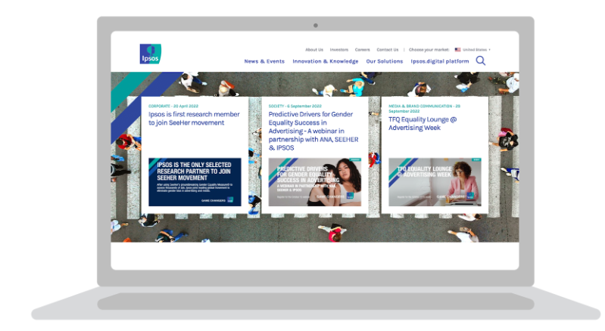

**Project background**

Ipsos’ client for this project was an online media company that allows users to post their own video content. The media company wanted to help its own clients - the advertisers on their platform - create the most effective ads. In particular, they wanted to find out whether investing in sequenced ads would increase the likelihood of viewers recalling an ad and purchasing a product. Video ad sequencing lets advertisers show ads in an order based on the most engaging and memorable story structures. The media company commissioned Ipsos to conduct research to measure the impact of five different sequence structures on brand lift.

**Note**: For the purpose of this case study, we will focus on only one sequence structure: Tease, Amplify, Echo. This sequence starts with a short ad to spark viewer curiosity (Tease); then, it moves on to a longer ad with more information to secure viewer engagement (Amplify); finally, it ends with a shorter ad that recaps the story and spurs viewers to action (Echo).

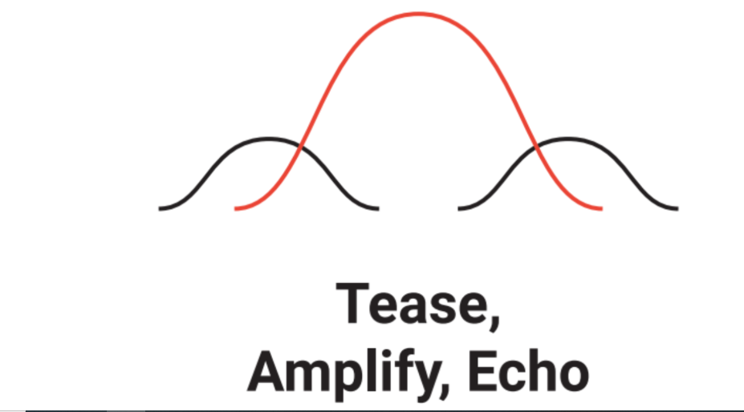

**Project framework**

Ipsos developed the following research question to guide their project: Does an ad sequence with the Tease, Amplify, Echo structure increase ad recall and purchase intent compared to repeated viewings of a traditional 30-second ad?

Ipsos’ initial hypothesis was that ads presented in a sequenced narrative would be more effective than repeated viewings of a traditional ad. To test this hypothesis for these two advertising approaches, Ipsos conducted an A/B test. The A/B test set up an experiment for two groups of users: one group was shown the Tease, Amplify, Echo ads and the other group was shown a traditional ad multiple times. In each case, the different ad formats were based on the same brand content. You’ll learn more about the details of the testing process in what follows.

**The challenges**

At the outset of the project, Ipsos identified two main challenges. The first challenge involved properly designing the A/B test. The second challenge involved creating the test ads in the appropriate test environment.

**Test design**

Ipsos’s primary concern was for the results of the A/B test to be generalizable, or applicable to the overall population of the media company’s users. In other words, Ipsos wanted to make valid inferences about the larger user population based on the smaller sample of test participants. To obtain valid test results, Ipsos needed to do the following;

1. Create a representative sample of test participants that mirrored the overall population of the media company’s users.
2. Create an online test environment that mirrored the media company’s online environment. This also implied creating test ads from multiple brands to reproduce the diversity of ads featured on the media company’s platform.

**The approach**

Despite these challenges, Ipsos conducted the A/B test and achieved their research goals. Ipsos’ successful approach to their project included the following elements:

* Team
* Sampling
* Testing process
* Hypothesis testing

**Team**

To build an effective team, Ipsos created a cross-functional operation, including video production to create test ads based on the Tease, Amplify, Echo structure, and technology to build a realistic online test environment.

To facilitate collaboration among project participants, Ipsos outlined a clear set of editing rules and organized a shared site to house links to videos and edit notes. This allowed rapid feedback and adjustment throughout the development process. Finally, Ipsos had senior client service project managers own and monitor the project design and workflow from beginning to end.

**Sampling**

Ipsos used random selection from consumer panels to generate a representative sample that accurately reflected the characteristics of the overall user population. Ipsos also made sure that each test group included the same proportion of respondents for key categories such as age and gender. Further, Ipsos used a relatively large sample size of 7,500 respondents to obtain more precise results.

**Testing process**

To get valid test results, Ipsos conducted A/B testing in an online environment where respondents used the media company’s platform as they typically would in their everyday lives. To mirror the diversity of ads on the platform, Ipsos developed test ads across 30 brand categories, from airline tickets to fast food to laundry detergent.

The testing process was organized in the following way:

Surveys were administered online via respondents’ smartphones in November and December of 2018. After initial screening, respondents were taken to a browser-based version of the platform where they were free to search for and watch videos as they normally would. Ipsos dynamically inserted test ads at the beginning of the videos selected by respondents in the live test environment. After the browsing session, respondents completed a survey to measure brand lift for ad recall and product intent.

**Hypothesis testing**

The survey data indicated that the Tease, Amplify, Echo ad sequence led to higher levels of ad recall and purchase intent among respondents than repeated viewings of a traditional ad. To determine whether their observed results were statistically significant, Ipsos conducted a two-sample t-test for each category: one for ad recall and one for purchase intent. They formulated their hypotheses as follows:

* **H**0: There is no difference in ad recall between sequenced ads and a repeated traditional ad.
* **H**a:There is a difference in ad recall intent between sequenced ads and a repeated traditional ad.
* **H**0: There is no difference in purchase intent between sequenced ads and a repeated traditional ad.
* **H**a:There is a difference in purchase intent between sequenced ads and a repeated traditional ad.

For both tests, Ipsos rejected the null hypothesis. They concluded that there are statistically significant and substantively meaningful differences in ad recall and purchase intent between sequenced ads and a repeated traditional ad.

**The results**

The results of the A/B test indicated that ad sequencing works!

The Tease, Amplify, Echo ad sequence had a significantly greater impact on ad recall and purchase intent than repeated viewings of a traditional ad. For example, across all product categories, 54% of viewers recalled the ad after being exposed to the “Tease, Amplify, Echo” sequence as compared to 42% with a repeated traditional ad. Further, 30% of viewers expressed intent to purchase after being exposed to the “Tease, Amplify, Echo” ad sequence as compared to 25% with a repeated traditional ad.

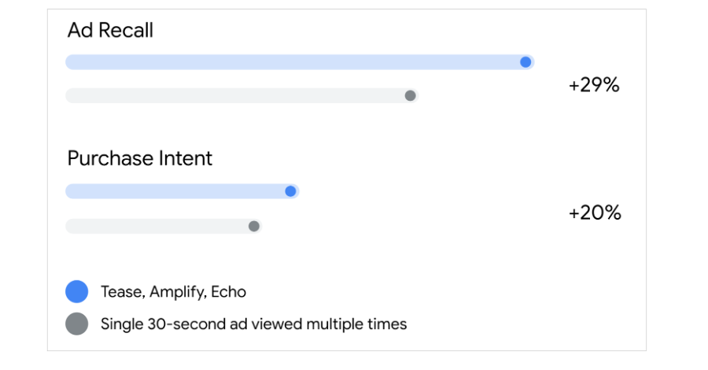

**Conclusion**

This case study on Ipsos’ A/B testing demonstrates the power of data-driven research to generate key business insights. The results of the A/B test clearly show how ad sequencing increases ad recall and purchase intent compared to repeated viewings of a traditional ad. Ipsos’s research on the benefits of ad sequencing helped the media company improve the experience and performance of the advertisers on their platform and added value to the media company’s brand.

**Resources**

Explore the following resources to learn more about the research project that inspired this case study:

* This [website from Think With Google](https://www.thinkwithgoogle.com/feature/youtube-ad-sequencing-and-ad-recall/ad-sequencing?lang=en_US) showcases the five sequencing structures involved in the research project.
* This one-pager from Ipsos offers a brief overview of the research project:

[Ipsos YouTube Ad Effectiveness.pdf](https://www.coursera.org/api/rest/v1/asset/download/pdf/ZNYX6phZQru37Fgv6bz7RA?pageStart=&pageEnd=" \t "_blank)

[PDF File](https://www.coursera.org/api/rest/v1/asset/download/pdf/ZNYX6phZQru37Fgv6bz7RA?pageStart=&pageEnd=" \t "_blank)

* This white paper from Ipsos provides a detailed summary of the methodology and results of the research project: